**Report Lab 04**

**E/15/271**

1. **Screenshots of the Design (proteus design)**

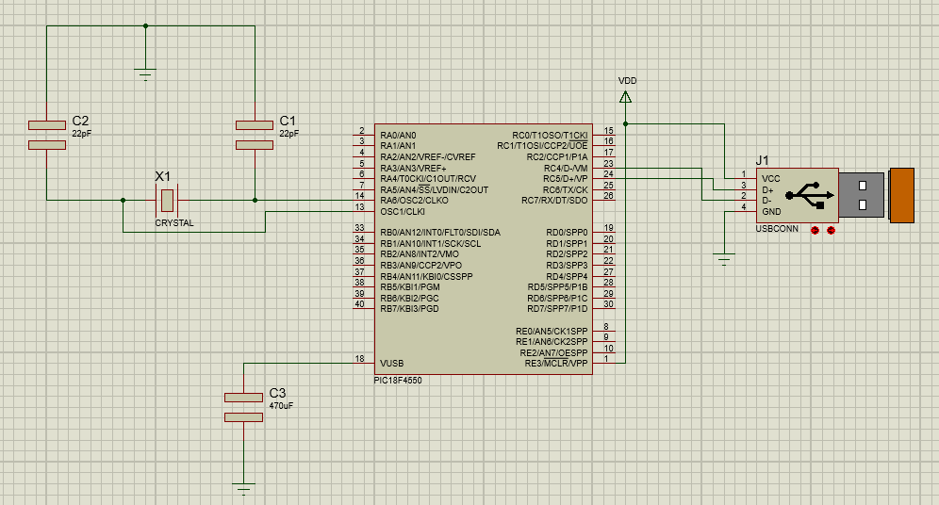

1. **Screenshots of Tera Term Terminal**

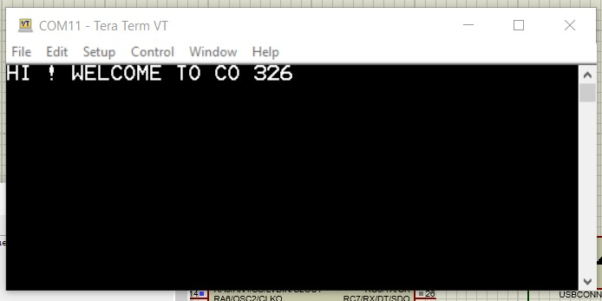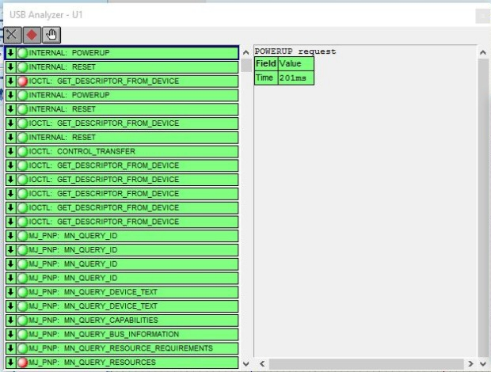

1. **Code from MPLAB for the Lab Task**

/** INCLUDES *******************************************************/

#include "system.h"

#include <stdint.h>

#include <string.h>

#include <stddef.h>

#include "usb.h"

#include "app_led_usb_status.h"

#include "app_device_cdc_basic.h"

#include "usb_config.h"

/** VARIABLES ******************************************************/

static bool buttonPressed;

static char buttonMessage[] = "Button pressed.\r\n";

static uint8_t readBuffer[CDC_DATA_OUT_EP_SIZE];

static uint8_t writeBuffer[CDC_DATA_IN_EP_SIZE];

uint8_t count = 0;

/*********************************************************************

* Function: void APP_DeviceCDCBasicDemoInitialize(void);

*

* Overview: Initializes the demo code

*

* PreCondition: None

*

* Input: None

*

* Output: None

*

********************************************************************/

void APP_DeviceCDCBasicDemoInitialize()

{

line_coding.bCharFormat = 0;

line_coding.bDataBits = 8;

line_coding.bParityType = 0;

line_coding.dwDTERate = 9600;

buttonPressed = false;

}

/*********************************************************************

* Function: void APP_DeviceCDCBasicDemoTasks(void);

*

* Overview: Keeps the demo running.

*

* PreCondition: The demo should have been initialized and started via

* the APP_DeviceCDCBasicDemoInitialize() and APP_DeviceCDCBasicDemoStart() demos

* respectively.

*

* Input: None

*

* Output: None

*

********************************************************************/

void APP_DeviceCDCBasicDemoTasks()

{

/* If the USB device isn't configured yet, we can't really do anything

* else since we don't have a host to talk to. So jump back to the

* top of the while loop. */

if(mUSBUSARTIsTxTrfReady() == true)

{

putrsUSBUSART("\0");

}

while(1){

if( USBGetDeviceState() < CONFIGURED_STATE )

{

return;

}

/* If we are currently suspended, then we need to see if we need to

* issue a remote wakeup. In either case, we shouldn't process any

* keyboard commands since we aren't currently communicating to the host

* thus just continue back to the start of the while loop. */

if( USBIsDeviceSuspended()== true )

{

return;

}

/* Check to see if there is a transmission in progress, if there isn't, then

* we can see about performing an echo response to data received.

*/

if( USBUSARTIsTxTrfReady() == true)

{

uint8_t i;

uint8_t numBytesRead;

numBytesRead = getsUSBUSART(readBuffer, sizeof(readBuffer));

/* For every byte that was read... */

for(i=0; i<numBytesRead; i++,count++)

{

if( (readBuffer[i]> 96) && (readBuffer[i]< 123))

{

writeBuffer[count] = readBuffer[i]- 32;

}else{

writeBuffer[count] = readBuffer[i];

}

}

if(readBuffer[i]==0x0A || readBuffer[i]==0x0D)

{

/* After processing all of the received data, we need to send out

* the "echo" data now.

*/

putUSBUSART(writeBuffer,count);

count = 0;

}

}

CDCTxService();

}

}

1. **Problems and issues you encountered and how you solved them**

* When build and clean the system.c file the MPLAB gives some errors and warnings. After changing the c99 standard to c90 standards it built successfully.
* Then the USB COM port does not appear in the device manager so update the mplab library to 2018 version (mla_v2018_11_26) and after reinstalling the virtual USB setup, then the problem was resolved.

1. **Explain followings**

* **Give a letter you typed and what is observed on the Tera Term**

The letter isn’t shown at tera term because anything does not appear in the tera terminal until the enter is pressed

* **Give screenshots of the USB monitor relevant to the letter you type and the letter displayed on the Tera Term.**

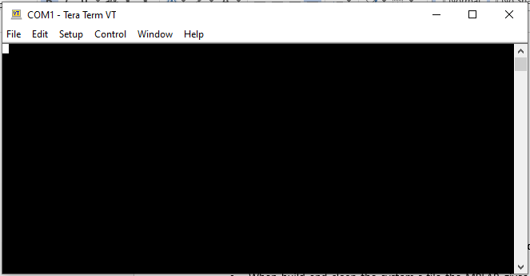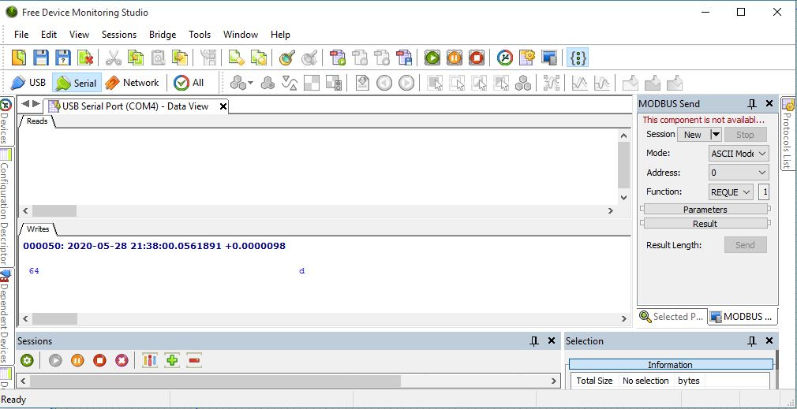

* **One type of packet is IN and other is OUT. Explain each case discussing why they become IN and OUT packets.**

In – This packet notifies the USB device that host wants to read information.

Out – This packet notifies the USB device that host wants to write information**.**

So in this case when a packet is IN it gets an error and when the packet type is OUT it run properly in the tera terminal.